CIPS
Oxana Rosca
2024-09-18
Do not use scientific notations
options(scipen = 999)
library(naniar)
library(readxl)
library(openxlsx)
library(dplyr)
##
## Attaching package: 'dplyr'
## The following objects are masked from 'package:stats':
##
## filter, lag
## The following objects are masked from 'package:base':
##
## intersect, setdiff, setequal, union
library(ggplot2)
library(EnvStats)
##
## Attaching package: 'EnvStats'
## The following objects are masked from 'package:stats':
##
## predict, predict.lm

Check the “NEW CIPS for matching (N=2047)”

Load “NEW CIPS for matching (N=2047)” clean dataset
without children with incarcerated mothers
cifs2047 <- as.data.frame(read_excel('CIFS_2047.xlsx'))
# # or
# cifs2047 <- as.data.frame(read_excel('NEW CIPS for matching (N=2047).xlsx'))
View(cifs2047)

Remove Children with missing values on AgeM
cifs2037 <- cifs2047[complete.cases(cifs2047$AgeM),]

Missing Data Analysis for cifs2037
library(naniar)
any_na(cifs2037)
## [1] TRUE
How many? Percentage?
n_miss(cifs2037)
## [1] 10146
prop_miss(cifs2037)
## [1] 0.1037678

880 missing values on age variable. In the original dataset: 1102
Get number of missings per variable (n and %)
# Convert 'pillar_num' columns to numeric
cifs2037_missing <- miss_var_summary(cifs2037) %>%
mutate(across(where(is.numeric), as.numeric))
# Display the data frame
cifs2037_missing
## # A tibble: 48 × 3
## variable n_miss pct_miss
## <chr> <dbl> <dbl>
## 1 reading 1551 76.1
## 2 pals 1547 75.9
## 3 memory 1546 75.9
## 4 concwrd 1546 75.9
## 5 PPVTSCAL 1171 57.5
## 6 AGEM_O 870 42.7
## 7 nreading 503 24.7
## 8 npals 502 24.6
## 9 nursrhym 501 24.6
## 10 educat 102 5.01
## # ℹ 38 more rows

Plot: Missingness on Variables
gg_miss_var(cifs2037)
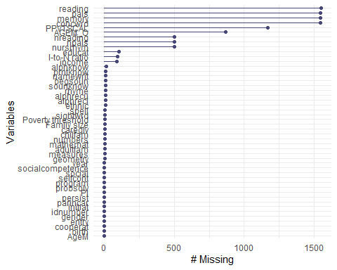

The dataset has 21 duplicate cases on the ID variable
table(duplicated(cifs2037$idnumber),useNA = 'always')
##
## FALSE TRUE <NA>
## 2016 21 0

Decision: Reject the ‘NEW CIPS for matching (N=2047).xlsx’ and clean the original dataset.

Clean and Organize the Original Dataset (N=2520).

Load 2520 original dataset (all children)
cips_2520 <- as.data.frame(read_excel('CIPS_2520.xlsx'))
View(cips_2520)

Create a variable of the row number in the original dataset
cips_2520 <- cips_2520 %>%
mutate(row.numberCIPS_2520 = row_number())

Remove 1102 Children with missing values on ageM
cifs_1418 <- cips_2520[complete.cases(cips_2520$AGEM),]

The dataset has 163 duplicate cases on the ID variable
table(duplicated(cifs_1418$idnumber),useNA = 'always')
##
## FALSE TRUE <NA>
## 1255 163 0

Missing Data Analysis for the original 1418 cases
any_na(cifs_1418)
## [1] TRUE
How many?
n_miss(cifs_1418)
## [1] 3151
prop_miss(cifs_1418)
## [1] 0.06172622

Get number of missings per variable (n and %)
# Convert 'pillar_num' columns to numeric
cifs_1418_missing <- miss_var_summary(cifs_1418) %>%
mutate(across(where(is.numeric), as.numeric))
# Write the modified data frame to an Excel file
write.xlsx(cifs_1418_missing, file = "cifs_1418_missing.xlsx")
# Display the data frame
cifs_1418_missing
## # A tibble: 36 × 3
## variable n_miss pct_miss
## <chr> <dbl> <dbl>
## 1 reading 829 58.5
## 2 pals 822 58.0
## 3 npals 612 43.2
## 4 nreading 612 43.2
## 5 I-to-N ratio 75 5.29
## 6 income 71 5.01
## 7 educat 63 4.44
## 8 alphknow 15 1.06
## 9 sightwrd 10 0.705
## 10 spell 9 0.635
## # ℹ 26 more rows

Plot: Missingness on Variables
gg_miss_var(cifs_1418)
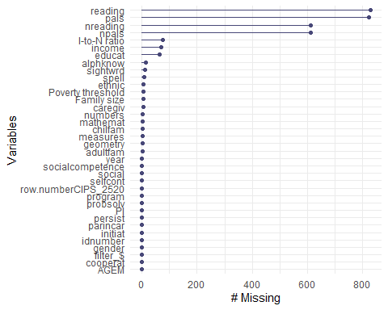

2-12 missings per participant
miss_case_summary(cifs_1418)
## # A tibble: 1,418 × 3
## case n_miss pct_miss
## <int> <int> <dbl>
## 1 460 11 30.6
## 2 365 8 22.2
## 3 205 7 19.4
## 4 230 7 19.4
## 5 309 7 19.4
## 6 680 7 19.4
## 7 687 7 19.4
## 8 711 7 19.4
## 9 713 7 19.4
## 10 820 7 19.4
## # ℹ 1,408 more rows
cifs_1418_missingPerCase<-miss_case_table(cifs_1418)
write.xlsx(cifs_1418_missingPerCase, file = "cifs_1418_missingPerCase.xlsx")
cifs_1418_missingPerCase
## # A tibble: 8 × 3
## n_miss_in_case n_cases pct_cases
## <int> <int> <dbl>
## 1 2 1253 88.4
## 2 3 63 4.44
## 3 4 83 5.85
## 4 5 5 0.353
## 5 6 4 0.282
## 6 7 8 0.564
## 7 8 1 0.0705
## 8 11 1 0.0705

Missing Plot
Where are missings located?
vis_miss(cifs_1418) + theme(axis.text.x = element_text(angle=80))
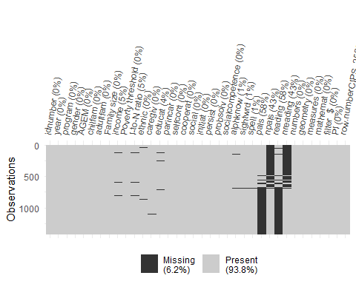 ## Remove factor of incarcerated mother. Subset 1394 rows: 139 with incarcerated fathers only and 1255 non-incarcerated parents “{0, No Parent Incarcerated} {1, Father Incarcerated} {2, Mother Incarcerated} {3, Both}”
table(cifs_1418$parincar, useNA = 'always')
##
## 0 1 2 3 9 <NA>
## 1255 139 22 1 1 0
Remove 24 rows:
cifs_1394<-cifs_1418[cifs_1418$parincar<2,]

Remove 157 Duplicated IDs

19 pairs of rows (38 rows) had identical IDs and the same year of program
duplicates_program_ID <- cifs_1394 %>%
group_by(idnumber, program) %>%
filter(n() > 1)
write.xlsx(duplicates_program_ID, file = "cifs_1394_DuplicateRecords_SameProgram.xlsx")
print(duplicates_program_ID)
## # A tibble: 38 × 36
## # Groups: idnumber, program [19]
## idnumber year program gender AGEM chilfam adultfam `Family size` income
## <dbl> <dbl> <dbl> <dbl> <dbl> <dbl> <dbl> <dbl> <dbl>
## 1 259 2 2 1 45 2 1 3 12574
## 2 259 3 2 1 57 2 2 4 NA
## 3 352 2 1 0 50 3 1 4 20909
## 4 352 2 1 0 50 3 1 4 20909
## 5 378 2 1 1 48 3 1 4 19818
## 6 378 2 1 0 48 2 1 3 7332
## 7 509 3 2 1 44 3 2 5 14150
## 8 509 4 2 1 56 4 2 6 14150
## 9 571 3 1 0 40 2 1 3 11456
## 10 571 4 1 0 52 2 1 3 11456
## # ℹ 28 more rows
## # ℹ 27 more variables: `Poverty threshold` <dbl>, `I-to-N ratio` <dbl>,
## # ethnic <dbl>, caregiv <dbl>, educat <dbl>, parincar <dbl>, selfcont <dbl>,
## # cooperat <dbl>, social <dbl>, initiat <dbl>, persist <dbl>, probsolv <dbl>,
## # socialcompetence <dbl>, alphknow <dbl>, sightwrd <dbl>, spell <dbl>,
## # pals <dbl>, npals <dbl>, reading <dbl>, nreading <dbl>, numbers <dbl>,
## # geometry <dbl>, measures <dbl>, mathemat <dbl>, `filter_$` <dbl>, …
table(duplicated(duplicates_program_ID$idnumber),useNA = 'always')
##
## FALSE TRUE <NA>
## 19 19 0

140 pairs of rows (380 rows) had identical IDs but different year of program
There were one or two sets of three rows with identical id numbers.
duplicates_program_ID2 <- cifs_1394 %>%
group_by(idnumber) %>%
filter(n() > 1) %>%
ungroup()
write.xlsx(duplicates_program_ID2, file = "cifs_1394_DuplicateRecords_DifProgram.xlsx")
print(duplicates_program_ID2)
## # A tibble: 314 × 36
## idnumber year program gender AGEM chilfam adultfam `Family size` income
## <dbl> <dbl> <dbl> <dbl> <dbl> <dbl> <dbl> <dbl> <dbl>
## 1 35 1 1 1 44 1 1 2 8434
## 2 35 2 2 1 56 1 1 2 8434
## 3 56 1 1 1 36 4 2 6 NA
## 4 56 2 2 1 48 4 2 6 NA
## 5 58 1 1 1 36 1 2 3 20000
## 6 58 2 2 1 48 1 2 3 20417
## 7 75 1 1 1 41 4 2 6 6576
## 8 75 2 2 1 53 3 1 4 6576
## 9 76 1 1 1 40 3 2 5 NA
## 10 76 2 2 1 52 3 1 4 NA
## # ℹ 304 more rows
## # ℹ 27 more variables: `Poverty threshold` <dbl>, `I-to-N ratio` <dbl>,
## # ethnic <dbl>, caregiv <dbl>, educat <dbl>, parincar <dbl>, selfcont <dbl>,
## # cooperat <dbl>, social <dbl>, initiat <dbl>, persist <dbl>, probsolv <dbl>,
## # socialcompetence <dbl>, alphknow <dbl>, sightwrd <dbl>, spell <dbl>,
## # pals <dbl>, npals <dbl>, reading <dbl>, nreading <dbl>, numbers <dbl>,
## # geometry <dbl>, measures <dbl>, mathemat <dbl>, `filter_$` <dbl>, …
table(duplicated(duplicates_program_ID2$idnumber),useNA = 'always')
##
## FALSE TRUE <NA>
## 157 157 0

Remove 157 Duplicated IDs
See the reasoning for removal in “cips_2520_data cleaning.xlsx”. “DuplicateRecords_SameProgram” and “DuplicateRecords_DifProgram”: Retain 157 green rows and remove 157 orange rows in the tab “Items to remove”
row.numberCIPS_2520_to_remove <- c(34, 55, 58, 72, 74, 76, 78, 80, 82, 84, 87,
90, 93, 96, 98, 100, 104, 106, 108, 132, 134, 136, 138, 141, 143, 145, 147,
149, 151, 154, 156, 158, 161, 163, 165, 167, 169, 171, 173, 175, 193, 216,
225, 242, 252, 259, 262, 273, 324, 335, 337, 355, 359, 384, 437, 444, 446,
452, 453, 455, 458, 461, 463, 465, 467, 470, 471, 473, 475, 479, 482, 484,
487, 496, 507, 510, 516, 540, 543, 547, 550, 552, 554, 556, 565, 580, 589,
597, 599, 602, 607, 616, 637, 651, 654, 657, 664, 674, 676, 678, 680, 683,
685, 687, 689, 691, 694, 696, 699, 701, 704, 708, 711, 717, 719, 721, 723,
725, 728, 730, 733, 736, 820, 822, 845, 848, 850, 852, 854, 856, 858, 874,
879, 901, 917, 920, 967, 969, 972, 975, 977, 979, 981, 986, 988, 998, 1002,
1016, 1018, 1020, 1025, 1032, 1054, 1087, 1097, 1130, 1755)
cifs_1237 <- cifs_1394 %>%
filter(!(row.numberCIPS_2520 %in% row.numberCIPS_2520_to_remove))

Adjust the missing and wrong values
See the reasoning in “cips_2520_results” in the tabs “DuplicateRecords_DifProgram” and “DuplicateRecords_SameProgram”

Change ‘program’ value from 2 to 1 for the row.numberCIPS_2520=272 (idnumber = 259)
cifs_1237[cifs_1237$row.numberCIPS_2520 == 272, "program"] <- 1

Change ‘program’ value from 1 to 2 for 8 specified row.numberCIPS_2520
id numbers are 811 854 987 1012 1018 1183 1186 1209
row.numberCIPS_2520_to_changeProgram <-
c(684,737,851,875,880,999,1003,1026)
cifs_1237 <- cifs_1237 %>%
mutate(program = ifelse(row.numberCIPS_2520 %in% row.numberCIPS_2520_to_changeProgram, 2, program))

Change “I-to-N ratio” variable’s name to avoid the space
names(cifs_1237)[names(cifs_1237) == "I-to-N ratio"] <- "I_to_N_ratio"

Incert missing values=0 into “income” and “I_to_N_ratio” for the specified row.numberCIPS_2520
id numbers are 56, 76, 138, 525, 1279.
row.numberCIPS_2520_to_changeIncome <- c(56, 75, 164, 445, 1088)
cifs_1237 <- cifs_1237 %>%
mutate(income = ifelse(row.numberCIPS_2520 %in% row.numberCIPS_2520_to_changeIncome, 0, income))
cifs_1237 <- cifs_1237 %>%
mutate(I_to_N_ratio = ifelse(row.numberCIPS_2520 %in% row.numberCIPS_2520_to_changeIncome, 0, I_to_N_ratio))

The dataset has no duplicate cases on the ID variable
table(duplicated(cifs_1237$idnumber),useNA = 'always')
##
## FALSE <NA>
## 1237 0

Missing Data Analysis for 1237 cases (clean dataset)
any_na(cifs_1237)
## [1] TRUE
How many?
n_miss(cifs_1237)
## [1] 2701
prop_miss(cifs_1237)
## [1] 0.06065301

880 missing values on age variable. In the original dataset: 1102
Get number of missings per variable (n and %)
# Convert 'pillar_num' columns to numeric
cifs_1237_missing <- miss_var_summary(cifs_1237) %>%
mutate(across(where(is.numeric), as.numeric))
# Display the data frame
cifs_1237_missing
## # A tibble: 36 × 3
## variable n_miss pct_miss
## <chr> <dbl> <dbl>
## 1 reading 751 60.7
## 2 pals 747 60.4
## 3 npals 500 40.4
## 4 nreading 500 40.4
## 5 I_to_N_ratio 56 4.53
## 6 income 52 4.20
## 7 educat 48 3.88
## 8 alphknow 9 0.728
## 9 ethnic 5 0.404
## 10 sightwrd 5 0.404
## # ℹ 26 more rows

Plot: Missingness on Variables
gg_miss_var(cifs_1237)
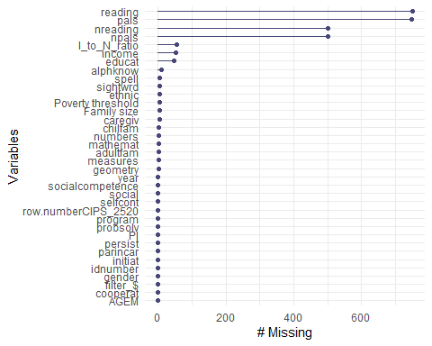

0-2 missings per participant
miss_case_summary(cifs_1237)
## # A tibble: 1,237 × 3
## case n_miss pct_miss
## <int> <int> <dbl>
## 1 387 11 30.6
## 2 300 8 22.2
## 3 158 7 19.4
## 4 181 7 19.4
## 5 250 7 19.4
## 6 580 7 19.4
## 7 41 6 16.7
## 8 257 6 16.7
## 9 901 6 16.7
## 10 94 5 13.9
## # ℹ 1,227 more rows
cifs_1237_missingPerCase<-miss_case_table(cifs_1418)
write.xlsx(cifs_1237_missingPerCase, file = "cifs_1418_missingPerCase.xlsx")
cifs_1237_missingPerCase
## # A tibble: 8 × 3
## n_miss_in_case n_cases pct_cases
## <int> <int> <dbl>
## 1 2 1253 88.4
## 2 3 63 4.44
## 3 4 83 5.85
## 4 5 5 0.353
## 5 6 4 0.282
## 6 7 8 0.564
## 7 8 1 0.0705
## 8 11 1 0.0705

Missing Plot
Where are missings located?
vis_miss(cifs_1237) + theme(axis.text.x = element_text(angle=80))
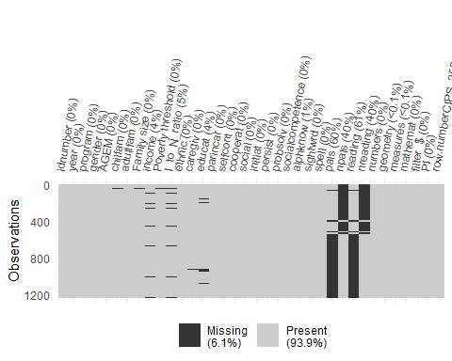

Getting the Analytical Sample (N=1181)

Remove 4 cases with missing values on family size and 52 cases with missing values on income
cifs_1233 <- cifs_1237[complete.cases(cifs_1237$`Family size`),]
AnSamp_cifs_1181 <- cifs_1233[complete.cases(cifs_1233$income),]

Analytic Sample Missing Plot
Where are missings located?
vis_miss(AnSamp_cifs_1181) + theme(axis.text.x = element_text(angle=80))
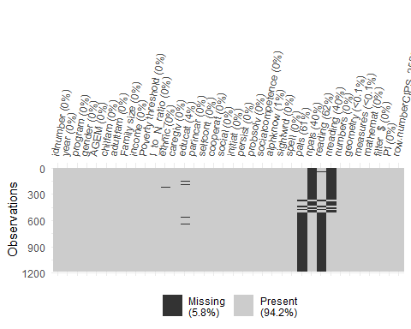

Check the summary of the dataset and save it as an Excel file
AnSamp_cifs_1181_summary<-summaryFull(AnSamp_cifs_1181)
## Warning in skewness(x = c(1, 1, 1, 1, 1, 1, 1, 1, 1, 1, 1, 1, 1, 1, 1, 1, : When method='fisher', 'x' must have at least 3 non-missing values and at least 2 must be distinct.
## Warning in kurtosis(x = c(1, 1, 1, 1, 1, 1, 1, 1, 1, 1, 1, 1, 1, 1, 1, 1, : When method='fisher', 'x' must have at least 4 non-missing values and at least 2 must be distinct.
AnSamp_cifs_1181_summary
## adultfam AGEM alphknow caregiv chilfam
## N 1181 1181 1172 1177 1181
## NA's 0 0 9 4 0
## N.Total 1181 1181 1181 1181 1181
## Mean 1.599 48.61 18.16 1.255 2.796
## Median 2 50 24 1 3
## 10% Trimmed Mean 1.524 49.3 19.39 1.003 2.663
## Skew 1.005 -1.507 -0.7569 4.643 0.992
## Kurtosis 1.467 5.921 -1.053 23.24 1.534
## Min 1 0 0 1 1
## Max 5 57 27 8 9
## Range 4 57 27 7 8
## 1st Quartile 1 46 9 1 2
## 3rd Quartile 2 53 26 1 4
## Standard Deviation 0.6573 5.98 9.566 0.9366 1.372
## Interquartile Range 1 7 17 0 2
## Median Absolute Deviation 1.483 5.93 2.965 0 1.483
## cooperat educat ethnic Family size filter_$
## N 1181 1134 1176 1181 1181
## NA's 0 47 5 0 0
## N.Total 1181 1181 1181 1181 1181
## Mean 9.545 11.5 3.936 4.395 1
## Median 10 12 4 4 1
## 10% Trimmed Mean 9.686 11.54 3.465 4.294 1
## Skew -0.4398 -0.7614 2.649 0.8296
## Kurtosis -0.1284 4.395 8.687 1.161
## Min 0 0 1 2 1
## Max 15 18 19 12 1
## Range 15 18 18 10 0
## 1st Quartile 7 11 2 3 1
## 3rd Quartile 12 12 5 5 1
## Standard Deviation 3.304 1.777 2.565 1.598 0
## Interquartile Range 5 1 3 2 0
## Median Absolute Deviation 2.965 1.483 1.483 1.483 0
## gender geometry I_to_N_ratio idnumber
## N 1181 1180 1181 1181
## NA's 0 1 0 0
## N.Total 1181 1181 1181 1181
## Mean 0.5241 13.68 0.5604 930.8
## Median 1 14 0.4911 898
## 10% Trimmed Mean 0.5302 14.12 0.5288 909
## Skew -0.09676 -0.9556 1.536 0.2426
## Kurtosis -1.994 0.7895 4.884 -1.032
## Min 0 0 0 1
## Max 1 21 2.764 2068
## Range 1 21 2.764 2067
## 1st Quartile 0 11 0.3223 401
## 3rd Quartile 1 17 0.7608 1381
## Standard Deviation 0.4996 4.319 0.3474 596.9
## Interquartile Range 1 6 0.4385 980
## Median Absolute Deviation 0 4.448 0.2992 725
## income initiat mathemat measures npals
## N 1181 1181 1179 1180 713
## NA's 0 0 2 1 468
## N.Total 1181 1181 1181 1181 1181
## Mean 11520 10.57 39.62 3.674 26.59
## Median 10060 11 40 4 20
## 10% Trimmed Mean 10780 10.77 39.45 3.831 23.2
## Skew 1.268 -0.5678 0.09484 -0.5105 1.441
## Kurtosis 2.681 0.2392 -0.2088 -0.9613 1.879
## Min 0 0 0 0 0
## Max 54630 15 81 6 113
## Range 54630 15 81 6 113
## 1st Quartile 6636 9 29 2 12
## 3rd Quartile 15060 12 51 5 34
## Standard Deviation 7177 3.06 16.14 1.935 22.14
## Interquartile Range 8424 3 22 3 22
## Median Absolute Deviation 5853 2.965 16.31 1.483 16.31
## nreading numbers pals parincar
## N 713 1179 458 1181
## NA's 468 2 723 0
## N.Total 1181 1181 1181 1181
## Mean 44.47 22.26 45.96 0.1025
## Median 40 21 44 0
## 10% Trimmed Mean 41.81 21.56 45.44 0.003175
## Skew 0.9226 0.4969 0.2248 2.625
## Kurtosis 0.8829 -0.04797 -0.06274 4.9
## Min 0 0 0 0
## Max 146 56 105 1
## Range 146 56 105 1
## 1st Quartile 25 13 32 0
## 3rd Quartile 58 30 59 0
## Standard Deviation 28.2 12.28 21.46 0.3034
## Interquartile Range 33 17 27 0
## Median Absolute Deviation 25.2 11.86 19.27 0
## persist PI Poverty threshold probsolv
## N 1181 1181 1181 1181
## NA's 0 0 0 0
## N.Total 1181 1181 1181 1181
## Mean 9.361 0.1025 21130 8.154
## Median 9 0 20520 9
## 10% Trimmed Mean 9.497 0.003175 20660 8.252
## Skew -0.4016 2.625 0.9081 -0.2326
## Kurtosis -0.1363 4.9 1.28 -0.2942
## Min 0 0 12400 0
## Max 15 1 45700 15
## Range 15 1 33300 15
## 1st Quartile 7 0 16690 6
## 3rd Quartile 12 0 24370 10
## Standard Deviation 3.468 0.3034 5588 3.636
## Interquartile Range 5 0 7680 4
## Median Absolute Deviation 4.448 0 5708 4.448
## program reading row.numberCIPS_2520 selfcont
## N 1181 454 1181 1181
## NA's 0 727 0 0
## N.Total 1181 1181 1181 1181
## Mean 1.257 70.64 804.3 16.55
## Median 1 66.5 772 17
## 10% Trimmed Mean 1.197 68.92 784.5 16.82
## Skew 1.111 0.4939 0.296 -0.5374
## Kurtosis -0.7667 0.3349 -0.9604 0.1149
## Min 1 0 1 0
## Max 2 179 1780 25
## Range 1 179 1779 25
## 1st Quartile 1 49 380 13
## 3rd Quartile 2 88.75 1171 20
## Standard Deviation 0.4374 34.08 500.7 5.379
## Interquartile Range 1 39.75 791 7
## Median Absolute Deviation 0 30.39 584.1 4.448
## sightwrd social socialcompetence spell
## N 1176 1181 1181 1176
## NA's 5 0 0 5
## N.Total 1181 1181 1181 1181
## Mean 0.2092 10.19 64.37 0.1531
## Median 0 11 66 0
## 10% Trimmed Mean 0 10.37 65.08 0
## Skew 10.96 -0.5581 -0.3816 8.171
## Kurtosis 161.5 0.08617 -0.06845 80.08
## Min 0 0 0 0
## Max 18 15 100 13
## Range 18 15 100 13
## 1st Quartile 0 8 52 0
## 3rd Quartile 0 12 78 0
## Standard Deviation 1.018 3.18 19.8 0.9255
## Interquartile Range 0 4 26 0
## Median Absolute Deviation 0 2.965 19.27 0
## year
## N 1181
## NA's 0
## N.Total 1181
## Mean 4.336
## Median 4
## 10% Trimmed Mean 4.295
## Skew 0.2396
## Kurtosis -1.014
## Min 1
## Max 8
## Range 7
## 1st Quartile 2
## 3rd Quartile 6
## Standard Deviation 2.28
## Interquartile Range 4
## Median Absolute Deviation 2.965
write.xlsx(AnSamp_cifs_1181_summary, file = "Analytic Sample cifs_1181 summary", rowNames = TRUE)

There are 121 children with incarcerated fathers and 1060 children without incarcerated parents.
table(AnSamp_cifs_1181$parincar, useNA = 'always')
##
## 0 1 <NA>
## 1060 121 0

